
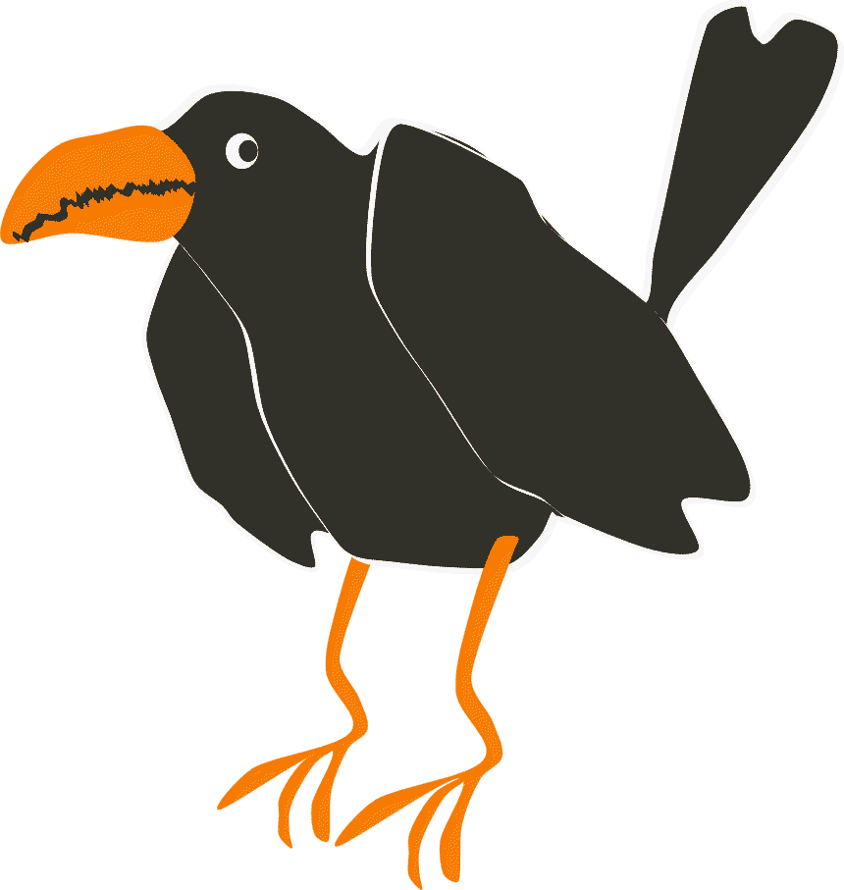
How to …
Clone frame and animate in DrawPlus X4 stop-frame mode

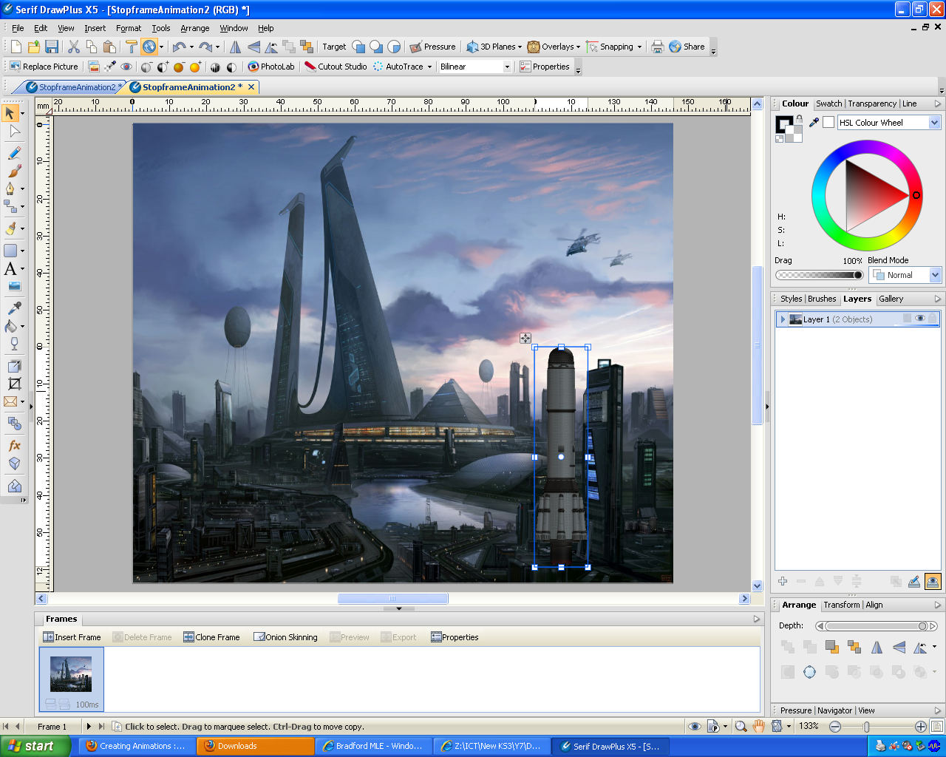
A
“Clone Frame” button

Add your additional image to your work area like what I did in the above screen shot. I have added a rocket which will be animated taking off just like I planned in my storyboard.

Notice the thumbnail picture of my work area at the bottom of the screen. (A) This is the start of my animation. I will click every time I my any of my object to build up a series of pictures of images moving across the screen.

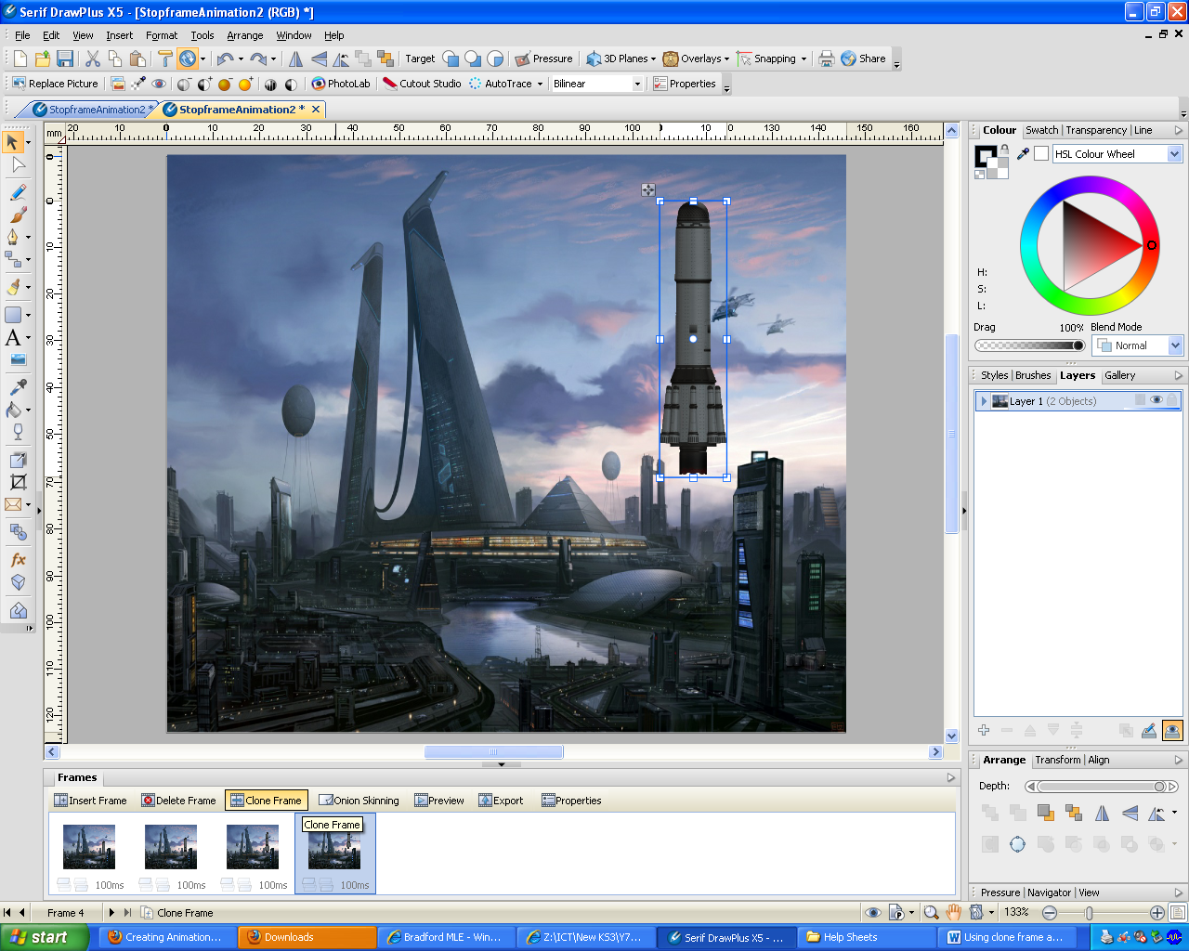

Move your images a little bit at a time then press “Clone Frame”. You can see my frames have been cloned four times so far and will continued to be cloned until your image reaches your chosen point “B”. When we take about direction of movement in animation it is oftenreffered to as point “A” to point “B”. “A” being the starting position of your image.

I can preview what I have done so far by pressing the “Preview” button.

